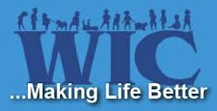





**Is WIC for you?**

WIC is for all kinds of families: Married and single parents, working or not working. If you are a father, mother, foster parent, grandparent or other legal guardian of a child under age five, you may be eligible for WIC.

**4 Locations to Serve You!**

**Fuller Clinic**

700 Fuller Ave NE

Grand Rapids, 49503

**North County Clinic**

4388 14 Mile Rd NE

Rockford, 49341

**Sheldon Clinic**

121 Franklin SE Suite 130

Grand Rapids, 49507

**South Clinic**

4700 Kalamazoo Ave SE

Kentwood, 49508

For more information:

[www.accesskent.com/wic](http://www.accesskent.com/wic) or to schedule a WIC Appointment, call:

1-616-632-7200

Or 1-888-515-1300



**To be eligible for WIC you must:**

1. Be a pregnant or breastfeeding woman, a new mother (up to 6 months after giving birth) or have an infant or child younger than 5 years of age that is in your care.
2. Meet nutritional or medical risk guidelines.
3. Live in Michigan
4. Meet income guidelines

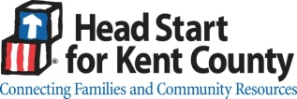

**WIC Provides:**

* Supplemental Food
* Nutrition Education
* High Risk Nutritional Counseling
* Healthcare & Social referrals
* Breastfeeding Promotion, Education & Support
* Project FRESH