Snack Smart

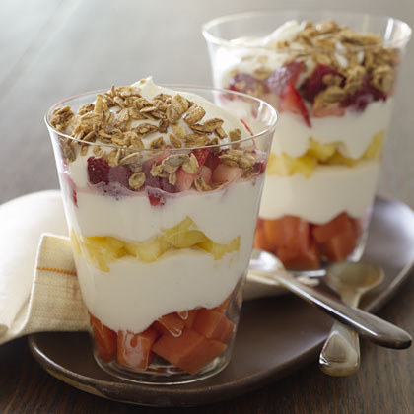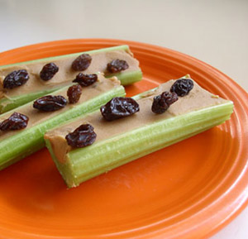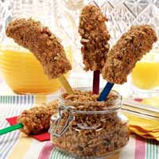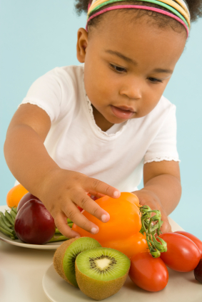

**Fun for Kids! Quick for Parents!**

1. Whole fruit, sliced into finger foods
2. Berries
3. Raw veggies cut up
4. Graham crackers
5. String cheese
6. Frozen Yogurt
7. Hardboiled egg
8. Cottage cheese
9. Pumpkin seeds

**Fruit Parfait:**

Layer fresh fruit,

yogurt, and

granola.

**Crunchy banana:**

Peel bananas. Roll them in peanut butter or yogurt, and crushed cereal. Freeze!

**Smart snacks can help your child eat and drink enough during the day. Most young children do best when they eat four to six times a day.**

**Time snacks carefully.** Two to three hours before meals is ideal so that your child will be hungry for lunch and dinner.

**Offer snacks to satisfy hunger.** Skip the urge to offer a snack to quiet tears, calm your child or reward behavior.

**Keep snacks small.** If your child is still hungry, they can ask for more. Let them decided how much is enough.

**Encourage tooth brushing after snacks** especially after bread, crackers, and sweet snacks.

**Snack wisely yourself.** Remember your child learns by watching your habits

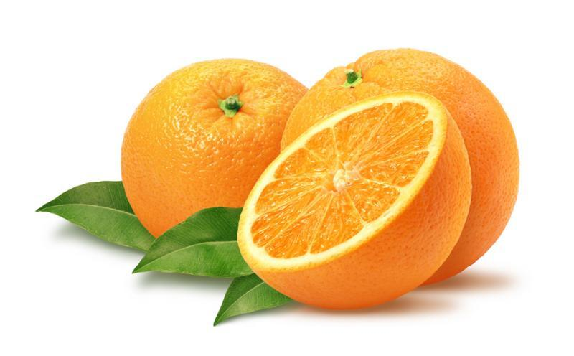

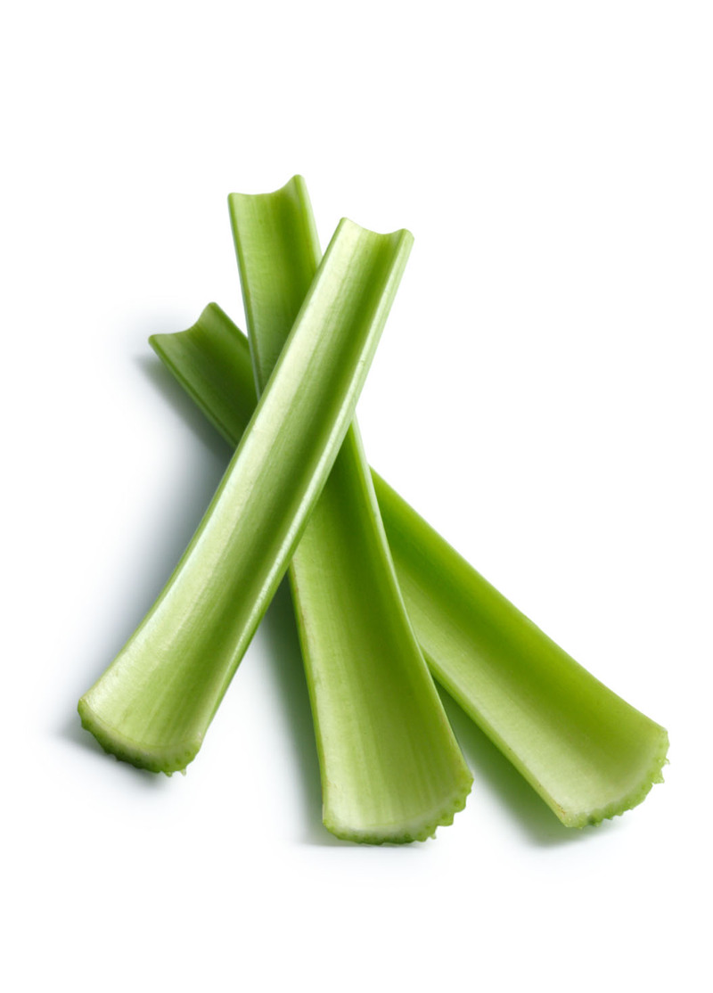

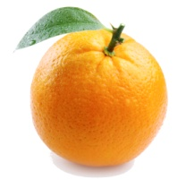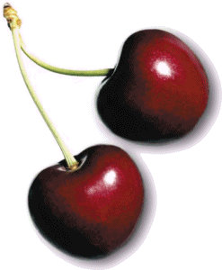

**Celery Surprise:** Spread peanut butter onto celery and sprinkle raisins on top.