**Drinks Really Do Matter!**



The habits children develop now greatly affect their health and will continue to benefit them well into their adult lives!

**What you should know about the health consequences of drinking sugar sweetened beverages:**

* Soda and sugar sweetened beverages can cause weight gain; 1 can of soda per day for a year could cause 12lbs of excess weight
* Excess weight puts you at risk for type 2 diabetes
* Sugar sweetened beverages contribute to tooth decay
* Drinking soda can increase the risk of osteoporosis



|  |  |  |
| --- | --- | --- |
| **How Much Sugar Am I Drinking?** | | |
|  |  | Teaspoons of Sugar (tsp) |
| Water (8oz) |  | 0 tsp |
| Low Fat Milk (8oz) |  | 2.75 tsp |
| 100% Juice (8oz) |  | 5.5 tsp |
| 10% Juice (8oz) |  | 9.5 tsp |
| Powdered Drink w/ Sugar Added (8oz) |  | 6 tsp |
| Soda (8oz) |  | 6.75 tsp |

**Smart Beverage Tips for a Healthier, Happier Child**

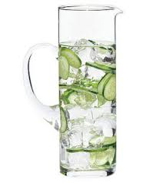

This handout is not a substitute for professional medical care. If you have questions or concerns, please talk with a health care provider.

Portions used from Journey Works Publishing.