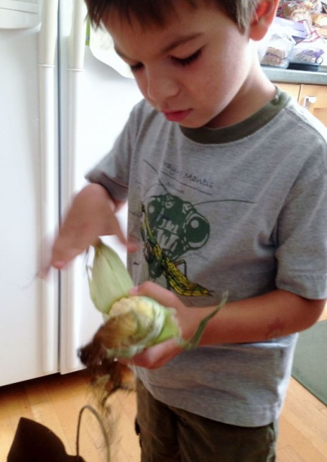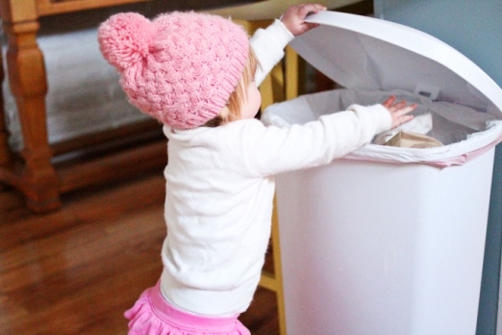[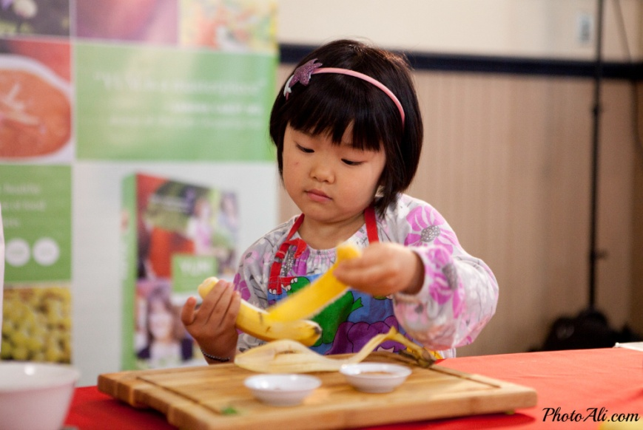](http://www.google.com/url?sa=i&rct=j&q=&esrc=s&source=images&cd=&cad=rja&uact=8&ved=0ahUKEwjDi_3O-cXLAhXI4CYKHepuANYQjRwIBw&url=http://yumfoodforliving.com/cooking-with-kids-yum-food-revolution/&psig=AFQjCNH5nsaWgZS1fl5Rmg21DovGwIVtsA&ust=1458243233498962)****

**Age Appropriate Food Preparation Activities for**

***2 to 3 Year Olds*:**

* Wash vegetables
* Remove husks from Corn on Cob
* Wipe off table
* Tear lettuce
* Snap green beans
* Shape burgers and meatballs
* Peel banana
* Place items in trash
* Set the table
* Clear own place setting from the table
* Stir batter; Add ingredients
* Knead and shape dough

**Age Appropriate Food Preparation Activities for**

***4 to 5 Year Olds*:**

* Break eggs in a bowl
* Measure and mix ingredients
* Open packages
* Pour cereal, add milk, and pour water into glasses
* Make sandwiches
* Toss salads
* Wash non-breakable dishes, such as measuring spoons and cups
* Spreadables (peanut butter, cheese, dips) on crackers, fruit, and bread
* Name and count foods
* Help assemble a pizza, pancakes, etc.
* Peel clementines, bananas, hard boiled eggs, etc.
* Any activity stated for 2 to 3 year olds

1. Wash hands with soap and water.
2. Supervise all children, at all times!

**Before you Begin:**

**C**ooking **W**ith **C**hildren

**Meal Preparation**

**Children who are involved in the preparation of their meal develop more interest in eating food!**