**10 Effective Ways to Handle a “Choosy” Eater**

|  |  |
| --- | --- |
| 1. **Focus on your child’s positive eating behavior** not on the food! | 6. **Treat food cravings casually** since they don’t usually last long. |
| 1. **Provide just 2 or 3 choices,** not a huge array of food. Then let you child decide. | 7. **Substitute a similar food** if a child doesn’t like a certain food and then let your child decide. |
| 1. **Set reasonable time limits for the start and end of a meal** and then remove the plate quietly. What’s reasonable depends on each child. | 8. **Trust your child’s appetite** rather than force a child to eat everything on the plate. Forcing a child to eat more encourages overeating. |
| 1. **Consider what a child eats over several days**, not just at each meal. Most kids eat more food variety than a parent realizes. 2. **Serve food plain** and respect the “no foods touching” rule if that is important to your child. This will pass. | 9. **Avoid being a short order cook** by offering the same food for the whole family. Plan at least one food everyone will eat.  10. **Stay positive and avoid criticizing** or calling any child a “picky eater.” Children believe what you say! |

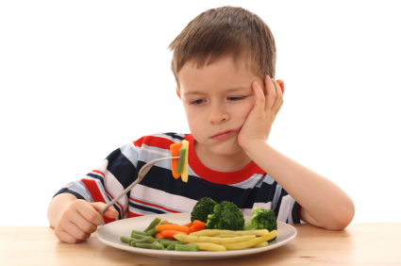

**The best advice for you: Relax and Be Patient!**

**Learn how to handle eating challenges and how to avoid conflict. That way, your child won’t learn to use food as a way to exert control.**

**“Choosy” eating is a child-size step toward growing up and showing independence.**

In fact, what seems like a challenge to you may be an early step toward making food choices. A child’s “No” doesn’t always mean no. What may seem “choosy” may just be your child’s awkward first steps in learning to make decisions.

**What appears to be “choosy” eating may instead be a smaller appetite.**

Preschool-age children grow and develop at a slower rate than toddlers do. If left alone, most children become hearty eaters again when their body’s growth pattern requires more food energy.